**lsatTS: an R package for generating vegetation greenness time series using Landsat satellite data**

Logan T. Berner1, Jakob J. Assmann2, Signe Normand2 and Scott J. Goetz1

1 School of Informatics, Computing, and Cyber Systems, Northern Arizona University, USA

2 Department of Biology – Ecoinformatic and Biodiversity, Aarhus University, Denmark

# Abstract

Earth-observing satellites are crucial for assessing and monitoring global ecosystems. The Landsat satellites provide near-global surface reflectance measurements since the early 1980s and are thus a cornerstone of remotely-sensed ecological assessments. Landsat reflectance measurements are commonly used to derive spectral indices (e.g., NDVI) that can provide insight into seasonal to multi-decadal changes in ecosystem biophysical properties such as vegetation greenness. Nevertheless, multiple factors impede multi-decadal assessments of spectral indices using Landsat satellite data, including ease of data access and cleaning, as well as challenges with cross-sensor calibration and irregular timing of cloud-free acquisitions. To help address these problems, we developed the *lsatTS* package for R. This software package facilitates sample-based time series analysis of spectral indices derived from Landsat surface reflectance measurements. The package includes functions that enable the extraction of the full Landsat record for point sample sites or small study regions using the Google Earth Engine accessed from R. Moreover, the package includes functions for (1) rigorous data cleaning, (2) cross-sensor calibration with machine learning, (3) phenological modeling, and (4) other aspects of data analysis. For an example application, we show how *lsatTS* can be used to assess changes in vegetation greenness since the 1980s across a long-term monitoring area on Disko Island in the Greenlandic Arctic. Overall, this software provides a suite of functions to enable broader use of Landsat satellite data for the assessment and monitoring of vegetation greenness over the past four decades across local to global geographic extents.

# Background

## Ecological monitoring using the Landsat satellites

Satellite remote sensing is crucial for understanding and monitoring how Earth’s land surface has changed during recent decades (National Academies of Sciences 2018). The Landsat satellites are particularly valuable in this regard because they are the longest continuously running satellite program and were designed for land surface monitoring at moderate spatial resolution (Wulder et al. 2019). The first Landsat satellite (Landsat 1) was launched in 1972 as a partnership between NASA and the US Geological Survey (USGS) and since that time a series of additional satellites have been launched, with the most recent being Landsat 9 in 2021. The Landsat satellites carry multi-spectral sensors that provide surface reflectance measurements used for a wide range scientific and land management applications (Wulder et al. 2019). These include, for instance, global monitoring of forest canopy cover (Hansen et al. 2013) and surface water extent (Pekel et al. 2016), as well as evaluating long-term changes in vegetation greenness that provide insight into how land-use and climate change are impacting terrestrial ecosystems (Wang and Friedl 2019, Berner et al. 2020). Hence, the Landsat program is a cornerstone of Earth surface monitoring.

## Impediments to Landsat time series analyses

In recent years, it has become easier to access, process, and analyze Landsat data; however, there are still challenges that hinder use of these data by ecologists, land managers, and other non-remote sensing specialists. The USGS made the Landsat archive publicly available in 2008 (Woodcock et al. 2008) and in recent years Google has hosted a copy of the archive accessible via the cloud-computing platform Google Earth Engine (GEE; Gorelick et al. 2017). These steps have made Landsat data much more readily available to the end user and enabled time series analyses of the Normalized Difference Vegetation Index (NDVI) and other spectral indices of “vegetation greenness” that correlate with productivity (Tucker 1979, Goetz and Prince 1999, Berner et al. 2020, Camps-Valls et al. 2021). However, time series analyses that use measurements from multiple sensors are hindered by systematic biases in both individual bands and spectral indices among the Landsat 5 Thematic Mapper (TM), Landsat 7 Enhanced Thematic Mapper Plus (ETM+), and Landsat 8 Operational Land Imager (OLI) (Ju and Masek 2016, Roy et al. 2016, Berner et al. 2020) sensors. If unaccounted for, these biases can introduce strong artificial trends into combined time series, such as spurious increases in NDVI over time (“greening”) (Sulla-Menashe et al. 2017). Existing approaches for cross-sensor calibration focus on linear corrections (Ju and Masek 2016, Roy et al. 2016), but not all relationships are linear and corrections are available for a limited number of spectral indices, like NDVI. Another potential hindrance when analyzing Landsat time series is the irregular timing of clear-sky acquisitions. This can make it challenging to characterize the NDVI or other spectral indices at a desired phenological stage (e.g., peak summer) and is especially problematic in regions with short growing seasons, such as the Arctic (Berner et al. 2020). Simple calculations of annual maximum NDVI will have a low bias early in the Landsat record, but less so during later years when more observations are available during each growing season. Hence, again, care is needed to avoid the introduction of spurious greening trends into the time series (Berner et al. 2020). While Landsat data are more readily available than ever before, there are lingering issues that present challenges to specialists and non-specialists alike.

## The lsatTS package

We developed the R package *lsatTS* to facilitate the sample-based time series analysis of spectral indices derived from surface reflectance measured by sensors on Landsat 5, 7, and 8. *lsatTS* grew out of recent research projects that assessed changes in vegetation greenness across the Arctic tundra and boreal forest biomes since the early 1980s (Berner et al. 2020, Berner and Goetz in review). The methodology has since been used in a variety of other research projects focused on specific aspects of tundra and boreal ecology (Boyd et al. 2019, Verdonen et al. 2020, Boyd et al. 2021, Gaglioti et al. 2021, Mekonnen et al. 2021, Walker et al. 2021). *lsatTS* provides novel functions that facilitate Landsat data extraction, preparation, and analysis within the free, open-source, and widely-used R software environment (R Core Team 2020). The R software environment for statistical computing runs on multiple computing platforms (UNIX, Windows, MacOS) and provides state-of-the-art tools for data analysis and visualization developed by a global user community (R Core Team 2020). Several R packages currently exist for processing Landsat data, including *landsat* (Goslee 2011) and *landsat8* (dos Santos 2017). *landsat* includes functions for radiometric and topographic correction of Landsat scenes, while *landsat8* includes functions for computing top of atmosphere reflectance, radiance, and/or brightness temperature on Landsat scenes. These existing packages provide valuable tools for processing individual Landsat scenes, but fundamentally differ from the functionality provided by *lsatTS.*

*lsatTS* offers an integrated framework for Landsat data extraction, processing, and time series analysis for sample locations anywhere on Earth’s surface. *lsatTS* includes functions for sample-based extraction of full data records from Landsat 5, 7, and 8 that is accomplished by querying the Landsat Collection 2 data set on GEE (Gorelick et al. 2017) using the application programming interface provided by the *rgee* package in R (Aybar et al. 2020). Further functions included in *lsatTS* facilitate (1) data cleaning, (2) cross-sensor calibration with machine learning, (3) characterization of growing season conditions using phenological modeling, and (4) other aspects of vegetation greenness time series analysis (Figure 1, Table 1). Unlike wall-to-wall analyses of the global span of the Landsat Collection, this sample-based framework is conducive to error propagation using Monte Carlo simulations. Overall, this software provides a suite of functions to enable broader use of Landsat satellite data for assessment and monitoring of Earth’s land surface over the past four decades in a sample-based framework suitable for local to global geographic extents.

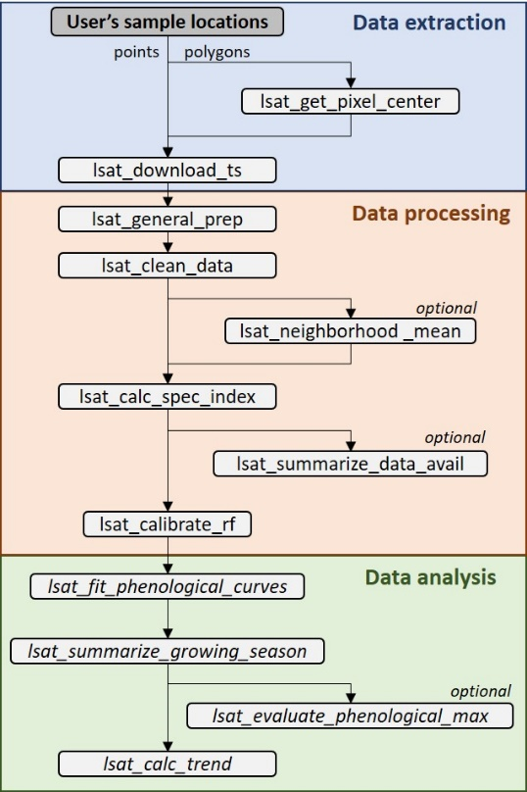

Figure 1. Schematic illustrating functions and typical workflow of the lsatTS package. Each function is described in the main text and Table 1.

Table 1. Function names and descriptions. These are listed in the order typically used.

|  |  |  |
| --- | --- | --- |
| **Step** | **Function** | **Description** |
| Data extraction | lsat_get_pixel_centers | Retrieve point coordinates of all Landsat 8 pixel centers that fall within a polygon. |
|  | Lsat_export_ts | Export full Landsat surface reflectance time series for a set of point coordinates using GEE accessed from R. |
| Data processing | lsat_general_prep | Prepare data exported from GEE, including parsing satellite names and renaming and scaling bands. |
|  | Lsat_clean_data | Filter out measurements based on presence of clouds, water, shadows, oblique view angles, and other criteria. |
|  | Lsat_summarize_data_avail | (*Optional*) Summarize data availability at each site, such as total number and years of observations. |
|  | Lsat_neighborhood_mean | (*Optional*) For buffered sites, compute band-wise mean surface reflectance across grid cells within the buffer. |
|  | Lsat_calc_spec_index | Calculate a variety of widely used spectral indices, such as the Normalized Difference Vegetation Index (NDVI). |
|  | Lsat_calibrate_rf | Cross-calibrate bands or spectral indices from Landsat 5/8 to match Landsat 7 using Random Forests. |
| Data analysis | lsat_fit_phenological_curves | Characterize seasonal land surface phenology at each site by iteratively fitting flexible cubic splines. |
|  | Lsat_summarize_growing_seasons | Estimate various phenological metrics from fitted cubic splines, such as annual maximum vegetation greenness. |
|  | Lsat_evaluate_phenological_max | (*Optional*) Evaluate estimates of annual maximum vegetation greenness with measurement availability. |
|  | Lsat_calc_trend | Calculate temporal trends using non-parametric Mann-Kendall trend tests and Theil-Sen slope indicators. |

# Package installation

The R package *lsatTS* is publicly available through a GitHub code repository. Users will need to have installed the R software environment on their computer. The *lsatTS* package is operating system agnostic and can be installed from within R using the *install_github()* function from the *devtools* package:

devtools::install_github("logan-berner/lsatTS")

The installation will compile the package from source code on the user’s computer. As the lsaTS package itself is exclusively written in R code, no additional software (such as Rtools) is required.

To use the data extraction and preparation functions, users will need an account on GEE and to have installed and configured the *rgee* package to assess GEE from R. Please see the GEE (<https://earthengine.google.com/>) and *rgee* (<https://r-spatial.github.io/rgee/>) websites for details on signing up for an account and configuring *rgee*, respectively.

All other external package dependencies are configured and dealt with by *devtools* automatically during the installation. These required packages include: magrittr, dplyr, tidyr, sf, crayon, mapview, purrr, data.table, ggplot2, R.utils, stats, stringr, ggpubr, ranger, zoo, and zyp.

# Data extraction

*lsatTS* allows for the point sample-based extraction of full Landsat data records from the GEE using the application programming interface provided by the *rgee* package. Data extraction is conducted using the function *lsat_export_ts()*. Should the user wish to extract the Landsat records for an area instead, then the optional *lstat_get_pixel_centers()* function can be used to obtain a regular grid of point-sample locations across the area of interest.

*Optional: Get central coordinates of pixels within a polygon using lsat_get_pixel_centers()*

The function *lsat_get_pixel_centers()* will determine the central coordinates of all Landsat pixels that fall within a user-specified polygon (supplied as simple feature collection). For this the function automatically determines the Landsat WRS scene whose center is closest to the center of the user-specified polygon. It then extracts the center coordinates for all pixels that overlap with the user-specified polygon from a Landsat 8 scene using the GEE. A buffer can be specified to include additional pixels out width the margin of the polygon. The function returns the pixel centers as an sf object, that can be passed on to the *lsat_exprt_ts()* function for the extraction of the Landsat time series.

*Export point-coordinate Landsat time series from Earth Engine using lsat_export_ts()*

The function *lsat_export_ts()* exports the whole record of Landsat 5, 7 and 8 observations for each sample site from the Landsat Collection 2 stored on the archives of the GEE. It is important to stress that this function only works for sample sites (point coordinates). These sample sites typically represent either (1) field site center coordinates, (2) a census of all Landsat pixels on a focal landscape (for example determined with *lsat_get_pixel_centers(*)), or (3) a random sample from a large region. The point coordinates need to be supplied as a simple feature collection of point geometries from the *sf* package. The function issues one or more tasks to GEE that export the data in form of comma separated value (CSV) files to the user’s Google Drive. The number of tasks issued varies depending on the number of point coordinates for which the Landsat record is to be extracted. Data extractions that involve a large number of sample sites are prone to errors and may exceed user limits set by the GEE. Therefore, the function will chunk the sample sites into small groups (by default 250 sites) and for each chunk will issue a separate export task to EE. The function returns a list of *rgee* task objects, which can be used to query the progress of the exports and subsequently retrieve the data from the user’s Google Drive.

# Data processing

## Prepare data for analysis using lsat_general_prep()

The function *lsat_general_prep()* takes the CSV files from the GEE exports by *lsat_exprot_ts()* and parses coordinates and other information, renames columns, and scales band values to allow for subsequent analysis using *lsatTS* functions. Please note that all *lsatTS* functions depend on there being a column called “sample.id” that uniquely identifies each location. If this column is not called “sample.id” in your dataset, then make sure to modify your column name accordingly.

## Clean surface reflectance data using lsat_clean_data()

Most analyses use high-quality surface reflectance measurements that were acquired under clear-sky conditions. You can filter surface reflectance measurements using *lsat_clean_data()*. This function allows you to filter measurements based on pixel quality flags and scene criteria. The USGS provides pixel quality flags based on the CFMask algorithm (Zhu et al. 2015) and information on each scene (e.g., cloud cover). The default settings for *lsat_clean_data()* will filter out measurements flagged as snow or water, as well as measurements acquired at high solar zenith angle (>60°), those with high geolocation uncertainty (>15 m), or those acquired as part of scenes with extensive cloud cover (>80%). Addition water masking is provided based on maxim surface water extent () from the Landsat-based JRC Global Surface Water Dataset (Pekel et al. 2016).

*Compute neighborhood mean surface reflectance using lsat_neighborhood_mean()*

If each of your sites were buffered to include a neighborhood of Landsat pixels (e.g., 3 x 3 pixels), then *lsat_neighborhood_mean()* will compute the mean reflectance across this neighborhood of pixels for measurements at each period in time.

*Summarize data availability for each site using lsat_summarize_data_avail()*

The function *lsat_summarize_data_avail()* creates a summary table that provides information on the period and number of observations available for each site. It also generates a figure showing the cross-site aggregate number of observations across years.

*Calculate spectral indices using lsat_calc_spec_index()*

Calculate common spectral indices using the function *lsat_calc_spec_index()*. This function includes ~15 spectral indices, including the Normalized Difference Vegetation Index (NDVI), 2-band Enhanced Vegetation Index (EVI2), and others (Table 2). Note the function can only compute one spectral index at a time.

Table 2. Spectral indices that can be computed using the *lsat_calc_spec_index()* function.

|  |  |  |  |
| --- | --- | --- | --- |
| **Name** | **Abbreviation** | **Formula** | **Citation** |
| Enhanced Vegetation Index | EVI |  | Huete et al. (2002) |
| Enhanced Vegetation Index (2-band) | EVI2 |  | Jiang et al. (2008) |
| Moisture Stress Index | MSI |  | Rock et al. (1986) |
| Near Infrared Vegetation Index | NIRv |  | Badgley et al. (2017) |
| Normalized Burn Ratio | NBR |  | Key and Benson (1999) |
| Normalized Difference Infrared Index | NDII |  | Hardisky et al. (1983) |
| Normalized Difference Moisture Index | NDMI |  | Gao (1996) |
| Normalized Difference Vegetation Index (red) | NDVI |  | Rouse et al. (1974) |
| Normalized Difference Vegetation Index (green) | gNDVI |  | Gitelson and Merzlyak (1998) |
| Normalized Difference Vegetation Index (kernel) | kNDVI | )2) | Camps-Valls et al. (2021) |
| Normalized Difference Water Index | NDWI |  | McFeeters (1996) |
| Plant Senescence Reflectance Index | PSRI |  | Merzlyak et al. (1999) |
| Soil Adjusted Vegetation Index | SAVI | 1.5 * | Huete (1988) |
| Soil Adjusted Total Vegetation Index | SATVI |  | Marsett et al. (2006) |
| Wide Dynamic Range Vegetation Index | WDRVI |  | (Gitelson 2004) |

## Cross-calibrate spectral reflectance or index across sensors using lsat_calibrate_rf()

The function *lsat_calibrate_rf()* will calibrate individual bands or spectral indices from Landsat 5 TM and Landsat 8 ETM+ to match Landsat 7 ETM using random forest models. This is needed because there are systematic differences in individual bands and spectral indices among Landsat sensors that should be addressed when combining data from multiple sensors (Ju and Masek 2016, Roy et al. 2016). The Landsat 7 ETM is used as a benchmark because it temporally overlaps with the other two sensors. Cross-calibration can only be performed on one band or spectral index at a time and requires having data from 100s to preferably many 1,000s of sample sites to train the random forest models. There is an option for users to train the random forest models using pre-processed Landsat data from ~6000 sample locations across the Arctic – Boreal domain. The overall approach involves determining the typical reflectance at a site during a portion of the growing season using Landsat 7 and Landsat 5/8 data that were collected the same years. A random forest model is then trained to predict Landsat 7 reflectance from Landsat 5/8 reflectance. Random forest models are ensembles of regression trees (Breiman 2001) that here are trained using a fast implementation provided by the *ranger* package (Wright and Ziegler 2017). If the user’s dataset includes both Landsat 5 and 8, then the function will train a random forest model for each sensor. By default, *lsat_calibrate_rf()* will add a new column with the cross-calibrated data ([band].xcal); however, the function will overwrite the existing column if overwrite.col = T. The function creates an output directory that contains (1) trained random forest models, (2) a CSV file with model evaluation metrics, and (3) a multi-panel figure comparing sensors pre- and post-calibration. If the default setting to add a new column with the cross-calibrated data is used, then either use those data in the subsequent functions (e.g., ndvi.xcal) or, once satisfied, manually overwrite the uncalibrated data to simplify subsequent column names.

# Data analysis

## Fit phenological curves to vegetation greenness time series using lsat_fit_phenological_curves()

The function *lsat_fit_phenological_curves()* characterizes seasonal land surface phenology at each sampling site using vegetation greenness (e.g., NDVI) time series from Landsat satellite observations. The function was constructed as a steppingstone to estimating annual maximum

vegetation greenness (e.g., NDVImax). The function iteratively fits cubic splines to seasonal vegetation greenness time series and returns information about the timing and magnitude of individual vegetation greenness observation relative to a multi-year seasonal phenology at

each site. The function was designed for spectral indices that are typically positive (e.g., NDVI). If you are working with a spectral index that is typically negative (e.g., NDWI) then multiply your index by -1 before running the *lsat_fit_phenological_curves()* and *lsat_summarize_growing_seasons()* functions and then back-transform afterwards

## Derived annual growing season metrics using lsat_summarize_growing_seasons()

The function *lsat_summarize_growing_seasons()* estimates several annual growing season metrics from vegetation greenness time series derived from Landsat satellite observations. The metrics include annual mean, median, and 90th percentile vegetation greenness of observations during each growing season, as well as phenologically-modeled estimates of annual maximum vegetation greenness and the seasonal timing (Day of Year) of maximum vegetation greenness. This function relies on output from *lsat_fit_phenological_curves()*.

## Evaluate estimates of annual max vegetation greenness using lsat_evaluate_phenological_max()

The function *lsat_evaluate_phenological_max()* is a tool for assessing how estimates of annual maximum vegetation greenness vary with the number of Landsat observations when derived from raw observations and after phenological modeling. Raw estimates of annual maximum vegetation greenness are sensitive to the number of observations available from a growing season, but the phenological modeling tends to substantially reduce this dependency. The algorithm assumes the “true” annual maximum vegetation greenness at a sample site is captured by having at least a user-specific number of observations (e.g., ≥ 7). The algorithm extracts site x years with at least this number of growing season observations and then compares how raw and phenologically-modeled estimates of maximum vegetation greenness change as a progressively smaller subsets of observations are used. This lets the user determine how much annual estimates of maximum vegetation greenness are impacted by the number of available growing season observations.

## Compute inter-annual trends in vegetation greenness using lsat_calc_trend()

The function *lsat_calc_trend()* computes a temporal trend in annual time series of vegetation greenness for each sampling site over a user-specified time period. This is a wrapper for the *zyp.yuepilon()* function from the *zyp* package (Bronaugh and Werner 2012). This function will iteratively pre-whiten a time series (i.e., remove temporal autocorrelation) and then compute Mann-Kendall trend tests and Theil-Sen slope indicators.

# Example application: Vegetation greenness trends for a landscape on Disko Island

Here we provide an example analysis of inter-annual changes in vegetation greenness from 2000 to 2020 across a ~4 km2 study area on Disko Island off the western coast of Greenland (Figure 2). The study area… We characterize annual maximum vegetation greenness using the Normalized Difference Vegetation Index (NDVImax) derived from Landsat satellite observations. Landsat NDVImax broadly correlates with tundra productivity and aboveground biomass (Berner et al. 2018, Berner et al. 2020). We focus on the period from 2000 to 2020 because there was limited Landsat data available prior to 2000. We provide the scripts associated with this example as supplemental files and in this section work through the analysis with example output figures and tables that are generated by the *lsatTS* functions (excluding Figure 2).

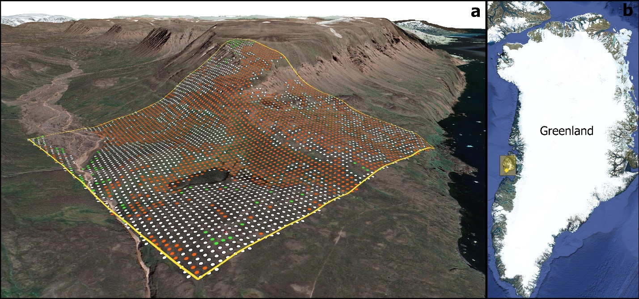

Figure 2. (a) Study area on Disko Island and (b) it’s location off the western coast of Greenland. Points in (a) show where Landsat annual maximum NDVI (NDVImax) systematically (α = 0.10) increased (green), decreased (brown), or did not change (white) from 2000 to 2020. Figure created using QGIS (version 3.20) with the background map from Google Satellite and underlying digital elevation model provide by the U.S. National Snow and Ice Data Center (Howat et al. 2014, Howat et al. 2015).

## Part 1: Export Landsat time series from Earth Engine

*# Load required R packages*

require(lsatTS)

require(rgee)

require(sf)

require(ggplot2)

require(data.table)

*# Initialize Earth Engine*

ee_Initialize()

*# Create a spatial polygon that demarcates the study area and transform to WGS84*

aoi.poly <- st_polygon(list(matrix(

c(-332950,-2243300,

-334950,-2243300,

-334950,-2245300,

-332950,-2245300,

-332950,-2243300),

ncol = 2, byrow = T)))

aoi.poly <- aoi.poly %>% st_sfc(crs = 3413) %>% st_transform(crs = 4326) %>% st_as_sf()

*# Get the central coordinates for each of the 4557 Landsat pixels in study area*

aoi.pts <- lsat_get_pixel_centers(aoi.poly)

*# Export summer Landsat surface reflectance measurements for each pixel to a folder called*

*# earth_engine/lsat_disko on Google Drive. This took ~2 days and exported 19 files totaling*

*# ~692 MB.*

lsat_export_ts(pixel_coords_sf = aoi.pts, startJulian = 152, endJulian = 273, prefix = 'disko', drive_export_dir = 'earth_engine/lsat_disko')

## Part 2: Derive vegetation greenness time series using Landsat data

*# Create a list of CSV files exported from GEE and then read them into R as a data.table object*

data.files <- list.files(‘~/earth_engine/lsat_disko’, full.names = T)

lsat.dt <- do.call("rbind", lapply(data.files, fread))

*# Format the exported data*

lsat.dt <- lsat_general_prep(lsat.dt)

*# Clean data by filtering clouds, snow, and water, as well as radiometric and geometric errors.*

*# This step* removed *1,817,683 of 2,452,693 observations (74.11%)*

lsat.dt <- lsat_clean_data(lsat.dt)

*# Summarize the availability of Landsat data for each pixel and save output figure (Figure 3)*

lsat_summarize_data_avail(lsat.dt)

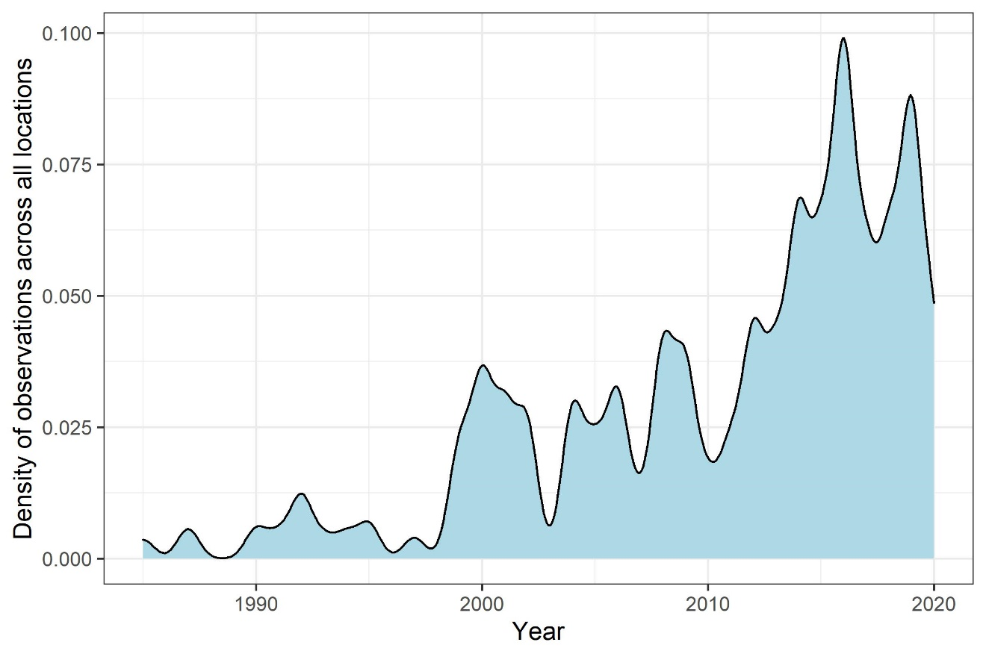

Figure 3. Availability of quality-screened summer Landsat satellite observations through time pooled across all sample locations in the study area on Disko Island. Landsat 5, 7, and 8 were launched in 1984, 1999, and 2013, respectively.

*# Compute the Normalized Difference Vegetation Index (NDVI)*

lsat.dt <- lsat_calc_spec_index(lsat.dt, si = 'ndvi')

*# Cross-calibrate NDVI among sensors using random forest models (Figure 4 and Table 3)*

lsat.dt <- lsat_calibrate_rf(lsat.dt, band.or.si = 'ndvi' train.with.highlat.data = T, outdir = 'output/ndvi_xcal_smry/', overwrite.col = T)

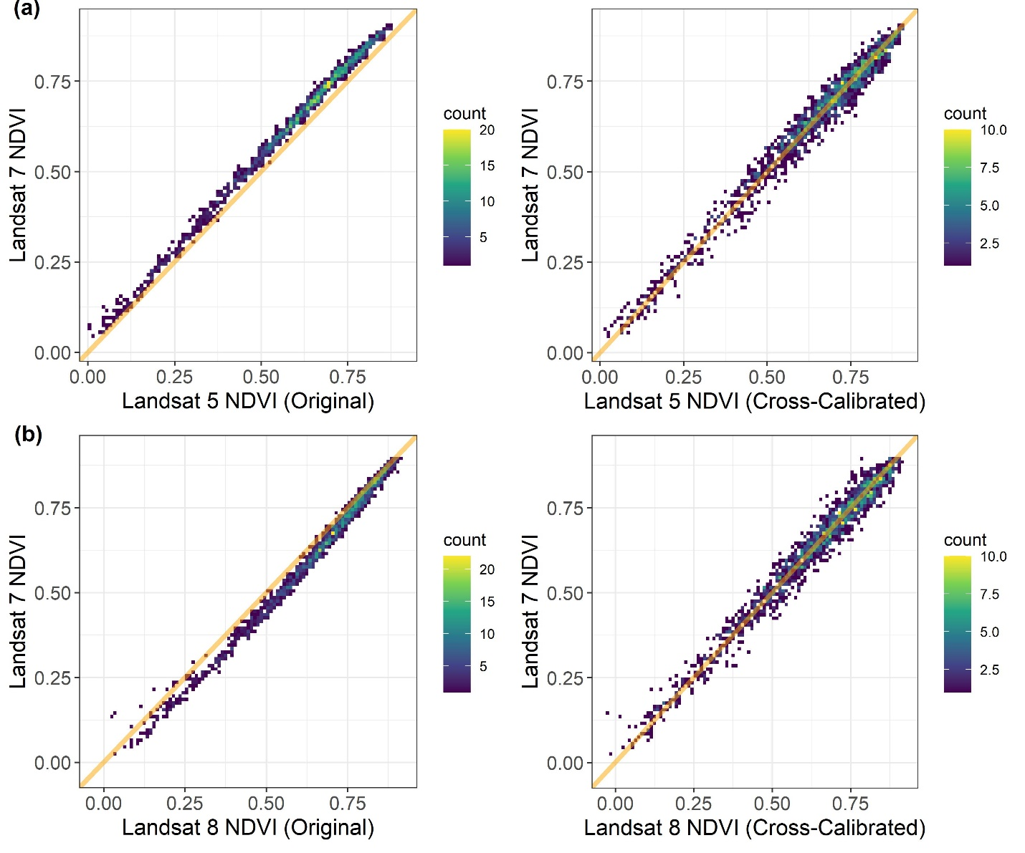

Figure 4. Relationships between Landsat 7 NDVI and both (a) Landsat 5 NDVI and (b) Landsat 8 NDVI using (left panels) original data and (right panels) data that were cross-calibrated with random forest models. Each point is a sample location from the Arctic – Boreal domain where there were temporally overlaps measurements from pairs Landsat satellites. Orange diagonal lines depict 1:1 relationships. Model performance metrics are provided in Table 3.

Table 3. Summary of original biases, performance of random forest models for cross-sensor calibration, and post-calibration biases in NDVI between Landsat 7 ETM and either Landsat 5 TM or Landsat 8 ETM+. Error metrics were derived internally by the random forest using out-of-bag (OOB, i.e., withheld) data and further assessed using cross-validation, which yielded nearly identical results albeit with further information on post-calibration biases.

|  |  |  |  |  |  |  |  |  |  |  |  |  |  |  |  |  |  |  |  |  |  |  |  |  |  |  |  |  |  |  |  |  |  |  |  |  |  |  |  |  |  |  |  |  |  |  |  |  |  |  |  |  |  |  |  |  |  |  |  |  |  |
| --- | --- | --- | --- | --- | --- | --- | --- | --- | --- | --- | --- | --- | --- | --- | --- | --- | --- | --- | --- | --- | --- | --- | --- | --- | --- | --- | --- | --- | --- | --- | --- | --- | --- | --- | --- | --- | --- | --- | --- | --- | --- | --- | --- | --- | --- | --- | --- | --- | --- | --- | --- | --- | --- | --- | --- | --- | --- | --- | --- | --- | --- |
| |  |  |  |  |  |  |  |  |  |  |  |  |  | | --- | --- | --- | --- | --- | --- | --- | --- | --- | --- | --- | --- | --- | | **Satellite**  **sensor** | **Original Data** | |  | **OOB Error Metrics** | | |  | **Cross-Validated Error Metrics** | | | | | | **Median**  **bias** | **Median**  **% bias** |  | **r2** | **RMSE** | **N** |  | **r2** | **RMSE** | **N** | **Median**  **bias** | **Median**  **% bias** | | Landsat 5 TM | -0.04 | -6.1 |  | 0.98 | 0.03 | 4315 |  | 0.98 | 0.03 | 1438 | +0.001 | +0.1 | | Landsat 8 ETM+ | +0.03 | +4.6 |  | 0.97 | 0.03 | 4881 |  | 0.97 | 0.03 | 1627 | -0.001 | -0.1 | |  | |  | | |  | | | | |
|  |  |  |  |  |  |  |  |  |  |

*# Fit phenological models (cubic splines) to time series at each sample location (Figure 5)*

lsat.pheno.dt <- lsat_fit_phenological_curves(lsat.dt, si = 'ndvi')

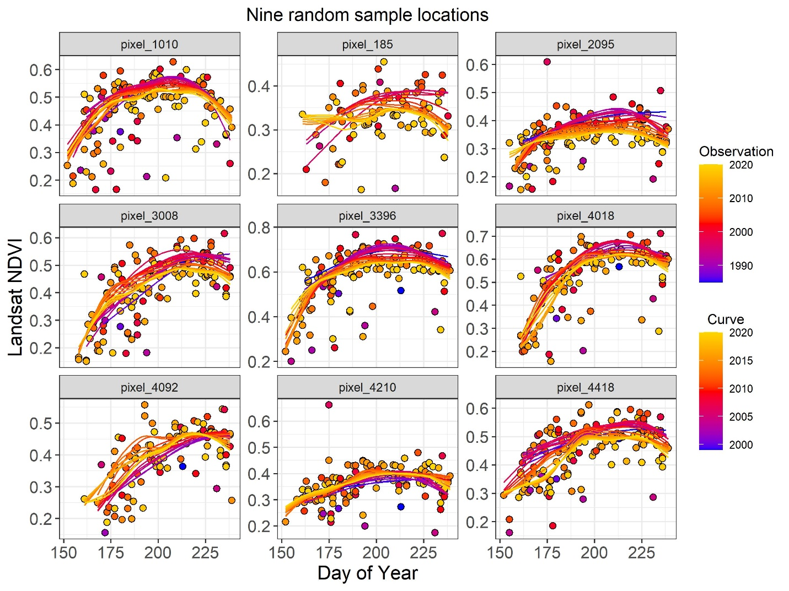

Figure 5. Examples of Landsat satellite observations and annual phenological curves for nine random sample locations from the study area of Disko Island.

*# Summarize spectral characteristics for each growing season*

lsat.gs.dt <- lsat_summarize_growing_seasons(lsat.pheno.dt, si = 'ndvi')

*# Evaluate the estimates of annual maximum NDVI (Figure 6)*

lsat.eval.dt <- lsat_evaluate_phenological_max(lsat.pheno.dt, si = 'ndvi')

Figure 6. Summary of how raw and modeled estimates of NDVImax vary with the number of Landsat satellite observations that are available in a given growing season. When only one or two observations are available from a growing season, then NDVImax tends to be systematically underestimated using raw data but not when using phenologically modeled.

## Part 3: Analyze vegetation greenness time series

*# Compute temporal trend in NDVImax (Figure 7)*

lsat.trend.dt <- lsat_calc_trend(lsat.gs.dt, si = 'ndvi.max', yrs = 2000:2020)

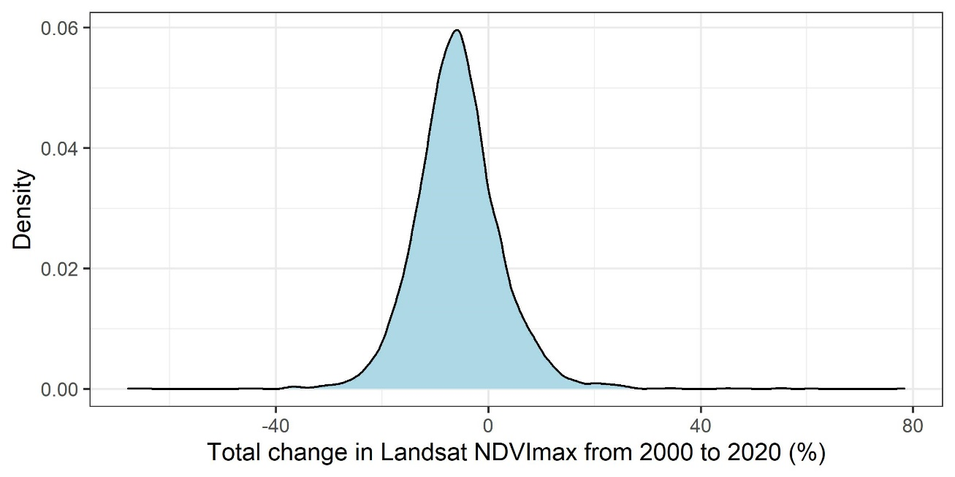

Figure 7. Distribution of total percent change in Landsat NDVImax from 2000 to 2020 among sample locations in the study area on Disko Island.

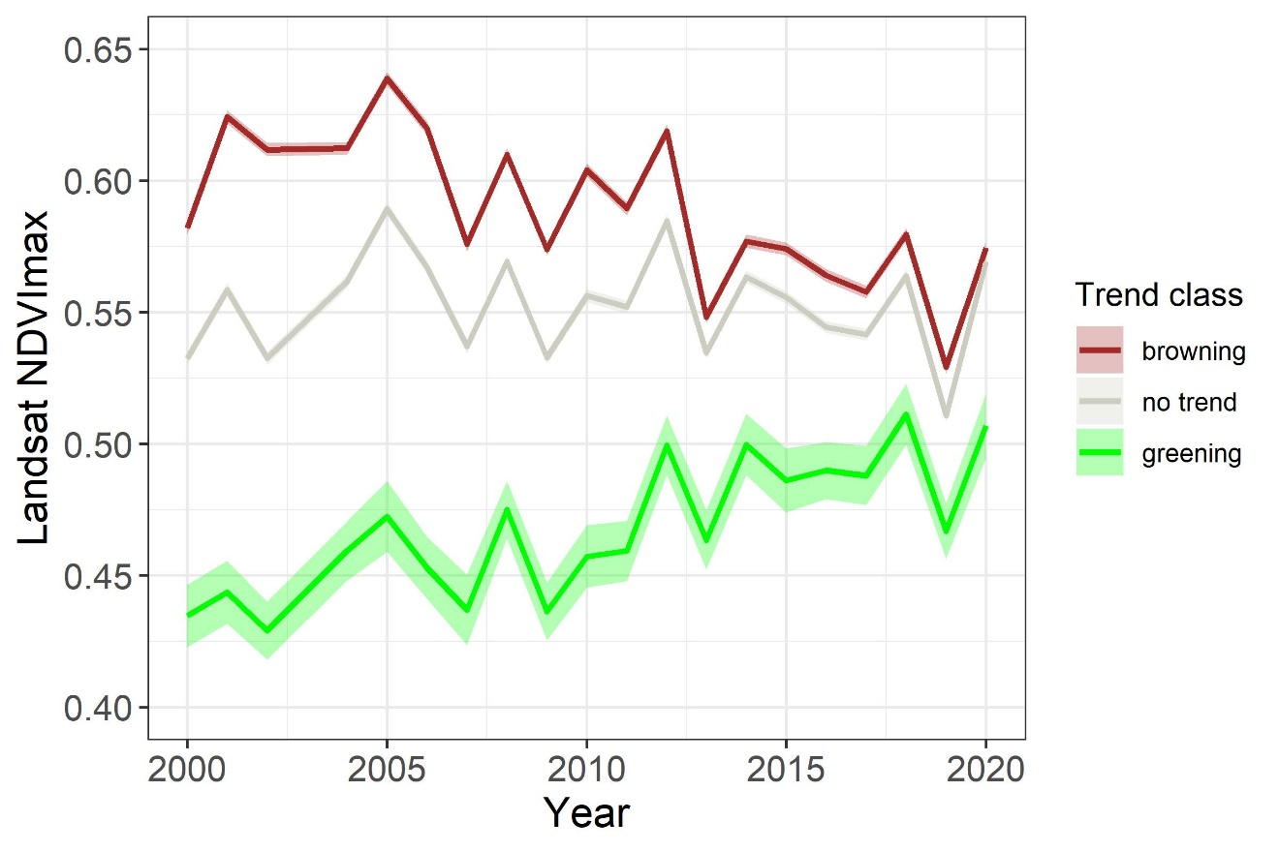

Figure 8. Annual mean Landsat NDVImax from 2000 to 2020 for sample locations grouped by their concomitant temporal trend. Trends were assessed for each sample location by removing temporal autocorrelation and then applying a Mann-Kendall trend test. Error bands depict ±1 standard error.

This example analysis showed that from 2000 to 2020, annual maximum vegetation greenness (i.e., NDVImax) systematically decreased (α = 0.10; browned) across 53% of the study area on Disko Island, whereas vegetation greenness systematically increased (α = 0.10; greened) across 2% of this study area (Figure 2a and 8). There were no systematic changes across the remaining 45% of the study area (Figure 2a and 8). Overall, vegetation greenness decreased by an average of 6.2 ± 8.4% (± 1 SD) during this period. The predominance of browning in this study area contrasts with widespread greening in the Arctic (Myers-Smith et al. 2020, Frost et al. 2021), where Landsat observations indicate that average vegetation greenness increased 3.9% from 2000 to 2020 (Berner et al. 2020, Mekonnen et al. 2021). Nevertheless, extensive browning in this study area is broadly consistent with findings from a recent pan-Arctic that detected regional browning in southwestern Greenland using the same Landsat processing as applied herein (Berner et al. 2020). Extensive browning in southwestern Greenland is potentially linked to hotter and dried conditions suppressing shrub growth, along with defoliation from moths (*Eurois occulta*) and browsing by muskoxen (*Ovibos moschatus*) (Forchhammer 2017, Gamm et al. 2018). This analysis demonstrates a general workflow that can be used to not only explore long-term changes in vegetation greenness across focal landscapes, but also to perform sample-based analyses across large geographic domains.

# Conclusion

The *lsatTS* package for R facilitates extracting and processing Landsat surface reflectance time series, as well as generating and analyzing metrics of vegetation greenness and other spectral indices. We demonstrate functionality of this software by analyzing changes in vegetation greenness across a tundra landscape on Disko Island off the west coast of Greenland, but underscore these tools are also well suited for sample-based analyses of vegetation dynamics across large geographic regions such as whole terrestrial biomes (e.g., Berner et al. 2020, Berner and Goetz in review). Overall, this software provides a suite of functions to enable broader use of Landsat satellite data for local to global assessment and monitoring of vegetation greenness and other spectral characteristics over the past four decades.

# Acknowledgements

This study was supported by the National Aeronautics and Space Administration (NASA) Arctic Boreal Vulnerability Experiment (ABoVE) under Grant No. NNX17AE44G to S.J. and the NASA New Investigator Program (NIP) under Grant No. 80NSSC21K1364 to L.T.B. This study was also supported by the National Science Foundation Navigating the New Arctic Big Idea under Grant No. 2127273 to L.T.B. and S.J.G.

# Literature cited

Aybar, C., Q. Wu, L. Bautista, R. Yali, and A. Barja. 2020. rgee: An R package for interacting with Google Earth Engine. Journal of Open Source Software **5**:2272.

Badgley, G., C. B. Field, and J. A. Berry. 2017. Canopy near-infrared reflectance and terrestrial photosynthesis. Science Advances **3**:e1602244.

Berner, L. T., and S. J. Goetz. in review. Satellite observations document trends consistent with a boreal forest biome shift. Global Change Biology.

Berner, L. T., P. Jantz, K. D. Tape, and S. J. Goetz. 2018. Tundra plant aboveground biomass and shrub dominance mapped across the North Slope of Alaska. Environmental Research Letters **13**:035002.

Berner, L. T., R. Massey, P. Jantz, B. C. Forbes, M. Macias-Fauria, I. H. Myers-Smith, T. Kumpula, G. Gauthier, L. Andreu-Hayles, B. Gaglioti, P. J. Burns, P. Zetterberg, R. D'Arrigo, and S. J. Goetz. 2020. Summer warming explains widespread but not uniform greening in the Arctic tundra biome. Nature communications **11**:4621.

Boyd, M. A., L. T. Berner, P. Doak, S. J. Goetz, B. M. Rogers, D. Wagner, X. J. Walker, and M. C. Mack. 2019. Impacts of climate and insect herbivory on productivity and physiology of trembling aspen (Populus tremuloides) in Alaskan boreal forests. Environmental Research Letters **14**:085010.

Boyd, M. A., L. T. Berner, A. C. Foster, S. J. Goetz, B. M. Rogers, X. J. Walker, and M. C. Mack. 2021. Historic declines in growth portend trembling aspen death during a contemporary leaf miner outbreak in Alaska. Ecosphere **12**:e03569.

Breiman, L. 2001. Random Forests. Machine Learning **45**:5-32.

Bronaugh, D., and A. Werner. 2012. zyp: Zhang + Yue-Pilon trends package. R package version 0.10-1.1. <https://CRAN.R-project.org/package=zyp>.

Camps-Valls, G., M. Campos-Taberner, Á. Moreno-Martínez, S. Walther, G. Duveiller, A. Cescatti, M. D. Mahecha, J. Muñoz-Marí, F. J. García-Haro, and L. Guanter. 2021. A unified vegetation index for quantifying the terrestrial biosphere. Science Advances **7**:eabc7447.

dos Santos, A. 2017. landsat8: Landsat 8 Imagery Rescaled to Reflectance, Radiance and/or Temperature. R package version 0.1-10. <https://CRAN.R-project.org/package=landsat8>.

Forchhammer, M. 2017. Sea-ice induced growth decline in Arctic shrubs. Biology Letters **13**.

Frost, G. V., M. J. Macander, U. S. Bhatt, H. E. Epstein, L. T. Berner, J. W. Bjerke, B. C. Forbes, S. J. Goetz, M. J. Lara, T. Park, G. K. Phoenix, M. K. Raynolds, H. Tømmervik, and D. A. Walker. 2021. Tundra greenness [in “State of the Climate in 2020”]. Bulletin of the American Meteorological Society **102**:S290–S292.

Gaglioti, B., L. T. Berner, B. M. Jones, K. M. Orndahl, A. P. Williams, L. Andreu‐Hayles, R. D’Arrigo, S. J. Goetz, and D. H. Mann. 2021. Tussocks enduring or shrubs greening: Alternate responses to changing fire regimes in the Noatak River Valley, Alaska. Journal of Geophysical Research: Biogeosciences **126**:e2020JG006009.

Gamm, C. M., P. F. Sullivan, A. Buchwal, R. J. Dial, A. B. Young, D. A. Watts, S. M. Cahoon, J. M. Welker, and E. Post. 2018. Declining growth of deciduous shrubs in the warming climate of continental western Greenland. Journal of Ecology **106**:640-654.

Gao, B.-C. 1996. NDWI—A normalized difference water index for remote sensing of vegetation liquid water from space. Remote Sensing of Environment **58**:257-266.

Gitelson, A. A. 2004. Wide dynamic range vegetation index for remote quantification of biophysical characteristics of vegetation. Journal of plant physiology **161**:165-173.

Gitelson, A. A., and M. N. Merzlyak. 1998. Remote sensing of chlorophyll concentration in higher plant leaves. Advances in Space Research **22**:689-692.

Goetz, S. J., and S. D. Prince. 1999. Modelling Terrestrial Carbon Exchange and Storage: Evidence and Implications of Fuctional Convergence in Light-use Efficiency. Advances in Ecological Research **28**:57-92.

Gorelick, N., M. Hancher, M. Dixon, S. Ilyushchenko, D. Thau, and R. Moore. 2017. Google Earth Engine: Planetary-scale geospatial analysis for everyone. Remote Sensing of Environment **202**:18-27.

Goslee, S. 2011. Analyzing remote sensing data in R: The Landsat Package. The Journal of Statistial Software **43**.

Hansen, M. C., P. V. Potapov, R. Moore, M. Hancher, S. A. Turubanova, A. Tyukavina, D. Thau, S. V. Stehman, S. J. Goetz, T. R. Loveland, A. Kommareddy, A. Egorov, L. Chini, C. O. Justice, and J. R. G. Townshend. 2013. High-Resolution Global Maps of 21st-Century Forest Cover Change. science **342**:850.

Hardisky, M., V. Klemas, and M. Smart. 1983. The influence of soil salinity, growth form, and leaf moisture on the spectral radiance of Spartina alterniflora. Photogrammetric Engineering & Remote Sensing **49**:77-83.

Howat, I., A. Negrete, and B. Smith. 2015. MEaSUREs Greenland Ice Mapping Project (GIMP) Digital Elevation Model, Version 1. NASA National Snow and Ice Data Center Distributed Active Archive Center. doi: <https://doi.org/10.5067/NV34YUIXLP9W>. [2021-11-23], Boulder, Colorado USA.

Howat, I. M., A. Negrete, and B. E. Smith. 2014. The Greenland Ice Mapping Project (GIMP) land classification and surface elevation data sets. The Cryosphere **8**:1509-1518.

Huete, A., K. Didan, T. Miura, E. P. Rodriguez, X. Gao, and L. G. Ferreira. 2002. Overview of the radiometric and biophysical performance of the MODIS vegetation indices. Remote Sensing of Environment **83**:195-213.

Huete, A. R. 1988. A soil-adjusted vegetation index (SAVI). Remote Sensing of Environment **25**:295-309.

Jiang, Z., A. R. Huete, K. Didan, and T. Miura. 2008. Development of a two-band enhanced vegetation index without a blue band. Remote Sensing of Environment **112**:3833-3845.

Ju, J., and J. G. Masek. 2016. The vegetation greenness trend in Canada and US Alaska from 1984–2012 Landsat data. Remote Sensing of Environment **176**:1-16.

Key, C. H., and N. C. Benson. 1999. The Normalized Burn Ratio (NBR): A Landsat TM radiometric measure of burn severity. United States Geological Survey, Northern Rocky Mountain Science Center.(Bozeman, MT).

Marsett, R. C., J. Qi, P. Heilman, S. H. Biedenbender, M. C. Watson, S. Amer, M. Weltz, D. Goodrich, and R. Marsett. 2006. Remote sensing for grassland management in the arid southwest. Rangeland Ecology & Management **59**:530-540.

McFeeters, S. K. 1996. The use of the Normalized Difference Water Index (NDWI) in the delineation of open water features. International Journal of Remote Sensing **17**:1425-1432.

Mekonnen, Z. A., W. J. Riley, L. T. Berner, N. J. Bouskill, M. S. Torn, G. Iwahana, A. L. Breen, I. H. Myers-Smith, M. G. Criado, Y. Liu, E. S. Euskirchen, S. J. Goetz, M. C. Mack, and R. F. Grant. 2021. Arctic tundra shrubification: a review of mechanisms and impacts on ecosystem carbon balance. Environmental Research Letters **16**:053001.

Merzlyak, M. N., A. A. Gitelson, O. B. Chivkunova, and V. Y. Rakitin. 1999. Non‐destructive optical detection of pigment changes during leaf senescence and fruit ripening. Physiologia plantarum **106**:135-141.

Myers-Smith, I. H., J. T. Kerby, G. K. Phoenix, J. W. Bjerke, H. E. Epstein, J. J. Assmann, C. John, L. Andreu-Hayles, S. Angers-Blondin, P. S. A. Beck, L. T. Berner, U. S. Bhatt, A. D. Bjorkman, D. Blok, A. Bryn, C. T. Christiansen, J. H. C. Cornelissen, A. M. Cunliffe, S. C. Elmendorf, B. C. Forbes, S. J. Goetz, R. D. Hollister, R. de Jong, M. M. Loranty, M. Macias-Fauria, K. Maseyk, S. Normand, J. Olofsson, T. C. Parker, F.-J. W. Parmentier, E. Post, G. Schaepman-Strub, F. Stordal, P. F. Sullivan, H. J. D. Thomas, H. Tømmervik, R. Treharne, C. E. Tweedie, D. A. Walker, M. Wilmking, and S. Wipf. 2020. Complexity revealed in the greening of the Arctic. Nature Climate Change **10**:106-117.

National Academies of Sciences. 2018. Thriving on Our Changing Planet: A Decadal Strategy for Earth Observation from Space. The National Academies Press, Washington, DC.

Pekel, J.-F., A. Cottam, N. Gorelick, and A. S. Belward. 2016. High-resolution mapping of global surface water and its long-term changes. Nature **540**:418-422.

R Core Team. 2020. R: A Language and Environment for Statistical Computing. R Foundation for Statistical Computing, Vienna.

Rock, B., J. Vogelmann, D. Williams, A. Vogelmann, and T. Hoshizaki. 1986. Remote detection of forest damage. BioScience **36**:439-445.

Rouse, J., R. Haas, J. Schell, and D. Deering. 1974. Monitoring vegetation systems in the Great Plains with ERTS. NASA special publication **351**:309-317.

Roy, D. P., V. Kovalskyy, H. K. Zhang, E. F. Vermote, L. Yan, S. S. Kumar, and A. Egorov. 2016. Characterization of Landsat-7 to Landsat-8 reflective wavelength and normalized difference vegetation index continuity. Remote Sensing of Environment **185**:57-70.

Tucker, C. J. 1979. Red and photographic infrared linear combinations for monitoring vegetation. Remote Sensing of Environment **8**:127-150.

Verdonen, M., L. T. Berner, B. C. Forbes, and T. Kumpula. 2020. Periglacial vegetation dynamics in Arctic Russia: decadal analysis of tundra regeneration on landslides with time series satellite imagery. Environmental Research Letters **15**:105020.

Walker, X. J., H. D. Alexander, L. T. Berner, M. A. Boyd, M. M. Loranty, S. M. Natali, and M. C. Mack. 2021. Positive response of tree productivity to warming is reversed by increased tree density at the Arctic tundra-taiga ecotone. Canadian Journal of Forest Research **51**:1323-1338.

Wang, J. A., and M. A. Friedl. 2019. The role of land cover change in Arctic-Boreal greening and browning trends. Environmental Research Letters **14**:125007.

Woodcock, C. E., R. Allen, M. Anderson, A. Belward, R. Bindschadler, W. Cohen, F. Gao, S. N. Goward, D. Helder, E. Helmer, R. Nemani, L. Oreopoulos, J. Schott, P. S. Thenkabail, E. F. Vermote, J. Vogelmann, M. A. Wulder, R. Wynne, and T. Landsat Sci. 2008. Free access to Landsat imagery. science **320**:1011-1011.

Wright, M. N., and A. Ziegler. 2017. Ranger: a fast implementation of random forests for high dimensional data in C++ and R. Journal of statistical software **77**:1-17.

Wulder, M. A., T. R. Loveland, D. P. Roy, C. J. Crawford, J. G. Masek, C. E. Woodcock, R. G. Allen, M. C. Anderson, A. S. Belward, W. B. Cohen, J. Dwyer, A. Erb, F. Gao, P. Griffiths, D. Helder, T. Hermosilla, J. D. Hipple, P. Hostert, M. J. Hughes, J. Huntington, D. M. Johnson, R. Kennedy, A. Kilic, Z. Li, L. Lymburner, J. McCorkel, N. Pahlevan, T. A. Scambos, C. Schaaf, J. R. Schott, Y. Sheng, J. Storey, E. Vermote, J. Vogelmann, J. C. White, R. H. Wynne, and Z. Zhu. 2019. Current status of Landsat program, science, and applications. Remote Sensing of Environment **225**:127-147.

Zhu, Z., S. Wang, and C. E. Woodcock. 2015. Improvement and expansion of the Fmask algorithm: cloud, cloud shadow, and snow detection for Landsats 4–7, 8, and Sentinel 2 images. Remote Sensing of Environment **159**:269-277.